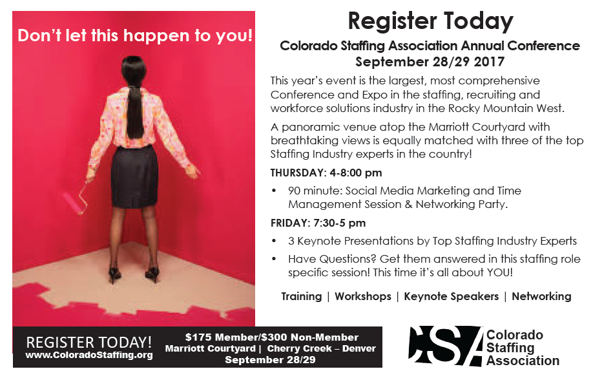
This year’s event is the largest, most comprehensive Conference and Expo in the staffing, recruiting and workforce solutions industry in the Rocky Mountain West. No other conference brings together this much expertise. Staffing industry vendors available to provide solutions to meet your every need.
3 Keynote Presentations by Top Staffing Industry Experts
Greg Doersching | Bullseye Mentor | Wisconsin | HR vs Recruiter Time to end the Cold War.
Jenifer Lambert | Terra Staffing Group | Seattle
Brad Bialy | Haley Marketing | New York
THURSDAY: 4-5:30 pm -- Brad Bialy, Haley Marketing
Brad will get you energized and better equipped for surviving in the social media jungle and also offer time management skills to get more done in less time! 6-8pm Networking Cocktail Party!
FRIDAY: 7:30 am-12pm -- Breakfast & Keynote Presentations
12-5 pm: Lunch & Breakout Sessions:
Have Questions? Get them answered in this staffing role specific session! It’s finally all about you!
Four Separate Breakout Sessions: Bring and issue or question you have to the room of experts. Each two hour session will be specific to your role and include two Staffing Industry Experts to facilitate. Choose one session for 2 hours or choose 2 for an hour each.
Here are a few examples of role specific issues:
Owners/Executives: A special 2 Hour Program with Jenifer Lambert presenting her incredible program entitled “It’s OK to be the Boss” and Charles Causey and his excellent program on “Your Company Culture”.
Sales: I need more clients! How do I get more calls returned? How do I stay motivated? What’s the best CRM?
Recruiting: Understanding Millennials? How do I stay ahead of the competition? Who has the best job board?
Accounting/HR: Oh no, what’s next for ACA? Healthcare options? Who has the best ATS? Paycards?
Meet with Staffing Industry Suppliers
CSAs Annual Conference features the industry’s leading suppliers—don’t miss the opportunity to meet with them one on one! Have your Best Sponsors Card complete by 5:00 pm and enter to win an Amazon Echo!

Hourly drawings for prizes and . . .
Your attendance automatically registers you to win a complimentary Certified Staffing Professional training/exam package from American Staffing Association – a $400-$800 value! Continuing Education Hours. Participation in this year’s conference, ASA-certified professionals can earn up to eight (8) continuing education hours.

Keynote Greg Doersching: HR vs Recruiter – time to end the Cold War.
I’ve never met a Recruiter yet who says, “I love HR people.” In fact, most Recruiters would love to pay some Voodoo Witch Doctor top dollar to put a curse on them all. Well it’s time to end this. The Human Resource department isn’t going away. HR people are ALWAYS going to be involved in recruiting efforts. So, let’s stop pointing fingers at them and complaining about all the things THEY don’t do and start focusing on what WE can do to make this a much more enjoyable working relationship. This is exactly what Greg Doersching will be talking about – proven tactics and tips to make HR people respect, respond, and reward the work you do. You won’t want to miss it.

$175 Member Pricing for Industry Partner Guests ($125 Savings!) | Marriott Courtyard | Cherry Creek – Denver
Register at www.Colorado Staffing.org

